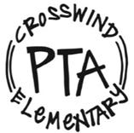
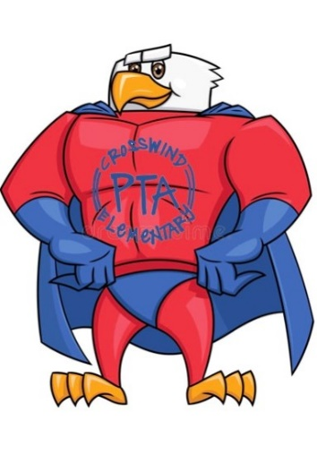

Dates to Remember

for 1st Semester

September 2 | Monthly Teacher Treats- 5th grade
September 7 | Labor Day- NO SCHOOL
September 15 | Collierville Food Pantry Collection
September 16 | 9:30am- Room Parent meeting/Q&A via Teams
September 17 | PTA Family Involvement Event: Pastries & Planes; Teams call with FedEx Pilots Kandy and Greg: grades K-2 @6pm, grades 3-5 @6:30pm
September 22 | PTA General Body Meeting via Teams 6pm (guest speaker: Beth McCallie, topic: internet safety)
October 7 | Monthly Teacher Treats- 4th grade
October 9 | Virtual Turkey Trot Pep Rally
October 12-16 | Fall Break- NO SCHOOL
October 20 | Collierville Food Pantry Collection, PTA Family Involvement Event: Pumpkins, Paints, and Superheroes (registration required)
October 26-30 | Red Ribbon Week
Oct 26-Nov 1 | Virtual Turkey Trot
November 2 | Vote Me In Election Day (Reading Programs event)
November 4 | Monthly Teacher Treats- 3rd grade
November 10 | PTA General Body Meeting via Teams 6pm
November 13 | PTA Reflections, Safety Poster, & Citizenship Essay Contest Deadlines
November 17 | Collierville Food Pantry Collection
November 20 | PTA Family Involvement Event: Gratitude is the Best Attitude (scavenger hunt, thank you note kits)
November 23-27 | Thanksgiving Holidays- NO SCHOOL
December 2 | Monthly Teacher Treats- PTA
December 4 | Virtual Turkey Trot Awards Program
December 12 | PTA Family Involvement Event: Kindness is Key (calendar, friendship bracelet craft)
December 15 | Collierville Food Pantry Collection
December 17 | Class Holiday Parties
December 18 | ½ Day- Students Dismiss at 12:15pm
Dec 21-Jan 5 | Winter Break- NO SCHOOL
January 6 | 1st Day of Second Semester for Students

